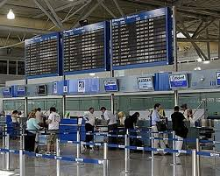

……………………......

**Χρήση:** ....................................................

**.**......................................................................

**Τι περιλαμβάνει:** ...........................................

................................................................................................................................................

**Που βρίσκεται:** .............................................

**Επισκέψεις:** .............................................

........................................................................

**Συναισθήματα:** .......................................................................................................................

**.**.................................................................................................................................................

**Αιτιολογία:** ........................................................................................................................

...................................................................................................................................................

**Συνολική περιγραφή:** .............................................................................................................

...................................................................................................................................................

...............................................................................................................................................................................................................................................................................................



……………………..........

**Χρήση:** ....................................................

**.**......................................................................

**Τι περιλαμβάνει:** ...........................................

................................................................................................................................................

**Που βρίσκεται:** .............................................

**Επισκέψεις:** .............................................

..................................................................................................................................................

**Συναισθήματα:** .......................................................................................................................

**.**.................................................................................................................................................

**Αιτιολογία:** ........................................................................................................................

...................................................................................................................................................

**Συνολική περιγραφή:** .............................................................................................................

...................................................................................................................................................

...............................................................................................................................................

.......................................................................................................................................

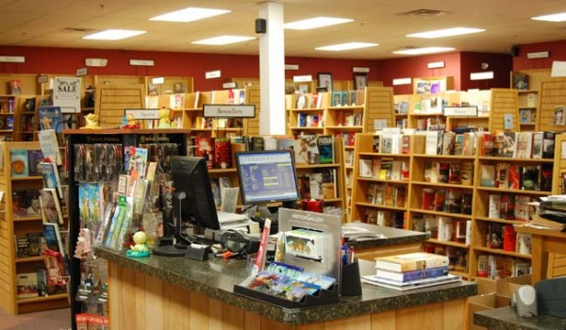

……………………......

**Χρήση:** ....................................................

**.**......................................................................

**Τι περιλαμβάνει:** ...........................................

................................................................................................................................................

........................................................................

**Που βρίσκεται:** .......................................................................................................................

**Επισκέψεις:** .......................................................................................................................

**Συναισθήματα:** .......................................................................................................................

**.**.................................................................................................................................................

**Αιτιολογία:** ........................................................................................................................

...................................................................................................................................................

**Συνολική περιγραφή:** .............................................................................................................

...................................................................................................................................................

...............................................................................................................................................................................................................................................................................................

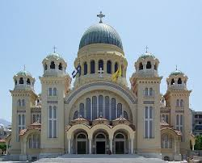…………………..........

**Χρήση:** ....................................................

**.**......................................................................

**Τι περιλαμβάνει:** ...........................................

........................................................................

**Που βρίσκεται:** .............................................

**Επισκέψεις:** .............................................

..................................................................................................................................................................................................................................................................................................

**Συναισθήματα:** ........................................................................................................................

**.**..................................................................................................................................................

**Αιτιολογία:** ........................................................................................................................

...................................................................................................................................................

**Συνολική περιγραφή:** .............................................................................................................

................................................................................................................................................

........................................................................................................................................

.......................................................................................................................................

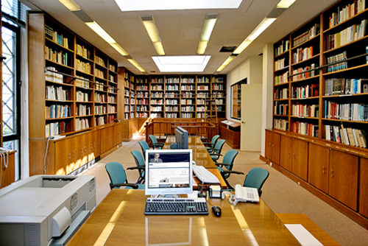

……………………......

**Χρήση:** ....................................................

**.**......................................................................

**Τι περιλαμβάνει:** ...........................................

................................................................................................................................................

**Που βρίσκεται:** .............................................

...................................................................................................................................................

**Επισκέψεις:** .....................................................................................................................

**Συναισθήματα:** .......................................................................................................................

**.**.................................................................................................................................................

**Αιτιολογία:** ........................................................................................................................

...................................................................................................................................................

**Συνολική περιγραφή:** .............................................................................................................

...................................................................................................................................................

...............................................................................................................................................................................................................................................................................................

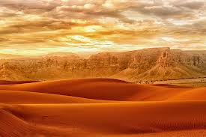

……………………..........

**Χρήση:** ....................................................

**.**......................................................................

**Τι περιλαμβάνει:** ...........................................

.........................................................................

**Που βρίσκεται:** .............................................

**.**................................................................................

**.**..................................................................................................................................................................

**Επισκέψεις:** .......................................................................................................................

**Συναισθήματα:** .......................................................................................................................

**.**.................................................................................................................................................

**Αιτιολογία:** ........................................................................................................................

...................................................................................................................................................

**Συνολική περιγραφή:** .............................................................................................................

...................................................................................................................................................

...............................................................................................................................................

........................................................................................................................................

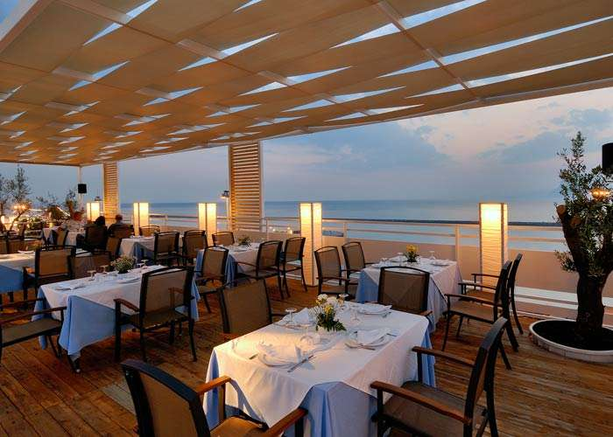

……………………......

**Χρήση:** ....................................................

**.**......................................................................

**Τι περιλαμβάνει:** ...........................................

................................................................................................................................................

**Που βρίσκεται:** .............................................

**Επισκέψεις:** .............................................

...................................................................................................................................................

**Συναισθήματα:** .......................................................................................................................

**.**.................................................................................................................................................

**Αιτιολογία:** ........................................................................................................................

...................................................................................................................................................

**Συνολική περιγραφή:** .............................................................................................................

...................................................................................................................................................

...............................................................................................................................................................................................................................................................................................

……………………..........

**Χρήση:** .......................................................

**.**.........................................................................

**Τι περιλαμβάνει:** ...........................................

..............................................................................................................................................................................................................................

**Που βρίσκεται:** ...............................................

**Επισκέψεις:** .......................................................................................................................

..................................................................................................................................................

**Συναισθήματα:** .......................................................................................................................

**.**.................................................................................................................................................

**Αιτιολογία:** ........................................................................................................................

...................................................................................................................................................

**Συνολική περιγραφή:** .............................................................................................................

...............................................................................................................................................

.........................................................................................................................................

.......................................................................................................................................

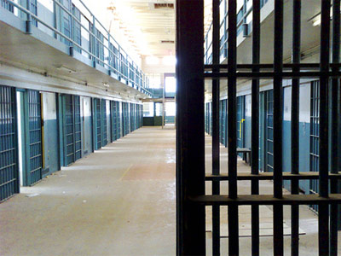

……………………......

**Χρήση:** ....................................................

**.**......................................................................

**Τι περιλαμβάνει:** ...........................................

................................................................................................................................................

**Που βρίσκεται:** .............................................

**Επισκέψεις:** .............................................

..................................................................................................................................................

**Συναισθήματα:** .......................................................................................................................

**.**.................................................................................................................................................

**Αιτιολογία:** ........................................................................................................................

...................................................................................................................................................

**Συνολική περιγραφή:** .............................................................................................................

...................................................................................................................................................

...............................................................................................................................................................................................................................................................................................

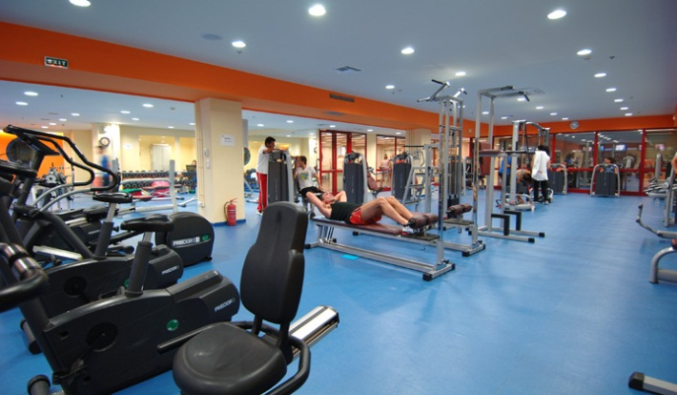

……………………..........

**Χρήση:** ....................................................

**.**......................................................................

**Τι περιλαμβάνει:** ...........................................

................................................................................................................................................

**Που βρίσκεται:** .......................................................................................................................

**Επισκέψεις:** .......................................................................................................................

..................................................................................................................................................

**Συναισθήματα:** .......................................................................................................................

**.**.................................................................................................................................................

**Αιτιολογία:** ........................................................................................................................

...................................................................................................................................................

**Συνολική περιγραφή:** .............................................................................................................

...................................................................................................................................................

...............................................................................................................................................

.......................................................................................................................................

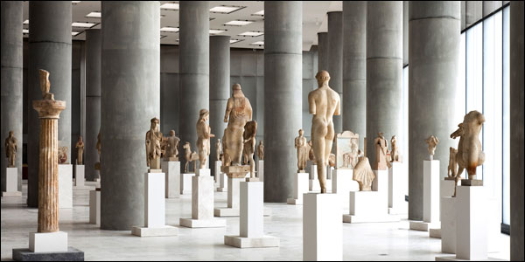

……………………......

**Χρήση:** ....................................................

**.**......................................................................

**Τι περιλαμβάνει:** ...........................................

...........................................................................................................................................................................................................................

**Που βρίσκεται:** .......................................................................................................................

**Επισκέψεις:** .......................................................................................................................

..................................................................................................................................................

**Συναισθήματα:** .......................................................................................................................

**.**.................................................................................................................................................

**Αιτιολογία:** ........................................................................................................................

...................................................................................................................................................

**Συνολική περιγραφή:** .............................................................................................................

...................................................................................................................................................

...............................................................................................................................................................................................................................................................................................

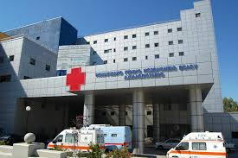

……………………..........

**Χρήση:** ....................................................

**.**......................................................................

**Τι περιλαμβάνει:** ...........................................

................................................................................................................................................

**Που βρίσκεται:** .............................................

**Επισκέψεις:** .......................................................................................................................

..................................................................................................................................................

**Συναισθήματα:** .......................................................................................................................

**.**.................................................................................................................................................

**Αιτιολογία:** ........................................................................................................................

...................................................................................................................................................

**Συνολική περιγραφή:** .............................................................................................................

...................................................................................................................................................

...............................................................................................................................................

.......................................................................................................................................

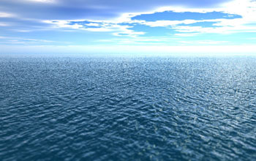

……………………......

**Χρήση:** ....................................................

**.**......................................................................

**Τι περιλαμβάνει:** ...........................................

................................................................................................................................................

**Που βρίσκεται:** .............................................

**.**..................................................................................................................................................................

**Επισκέψεις:** .......................................................................................................................

**Συναισθήματα:** .......................................................................................................................

**.**.................................................................................................................................................

**Αιτιολογία:** ........................................................................................................................

...................................................................................................................................................

**Συνολική περιγραφή:** .............................................................................................................

...................................................................................................................................................

...............................................................................................................................................................................................................................................................................................

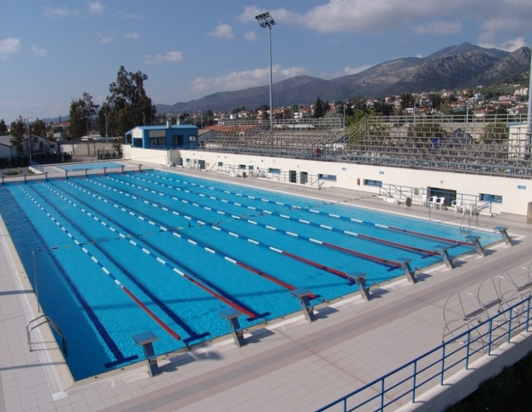

……………………..........

**Χρήση:** ....................................................

**.**......................................................................

**Τι περιλαμβάνει:** ...........................................

................................................................................................................................................

**Που βρίσκεται:** .............................................

**Επισκέψεις:** .............................................

..................................................................................................................................................

**Συναισθήματα:** .......................................................................................................................

**.**.................................................................................................................................................

**Αιτιολογία:** ........................................................................................................................

...................................................................................................................................................

**Συνολική περιγραφή:** .............................................................................................................

...................................................................................................................................................

...............................................................................................................................................

.......................................................................................................................................

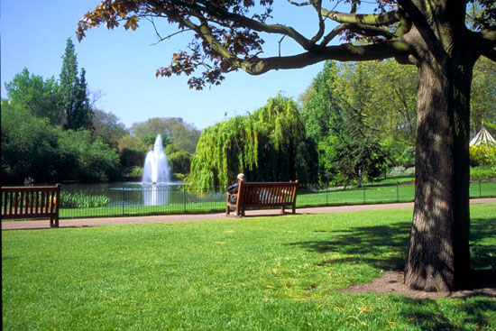

……………………......

**Χρήση:** ....................................................

**.**......................................................................

**Τι περιλαμβάνει:** ...........................................

................................................................................................................................................

**Που βρίσκεται:** .............................................

**Επισκέψεις:** .......................................................................................................................

..................................................................................................................................................

**Συναισθήματα:** .......................................................................................................................

**.**.................................................................................................................................................

**Αιτιολογία:** ........................................................................................................................

...................................................................................................................................................

**Συνολική περιγραφή:** .............................................................................................................

...................................................................................................................................................

...............................................................................................................................................................................................................................................................................................

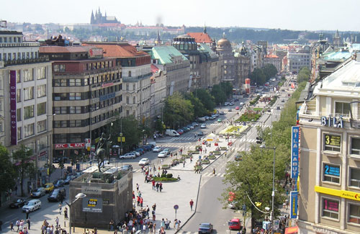

……………………..........

**Χρήση:** ....................................................

**.**......................................................................

**Τι περιλαμβάνει:** ...........................................

................................................................................................................................................

**Που βρίσκεται:** .......................................................................................................................

**Επισκέψεις:** .......................................................................................................................

..................................................................................................................................................

**Συναισθήματα:** .......................................................................................................................

**.**.................................................................................................................................................

**Αιτιολογία:** ........................................................................................................................

...................................................................................................................................................

**Συνολική περιγραφή:** .............................................................................................................

...................................................................................................................................................

...............................................................................................................................................

.......................................................................................................................................

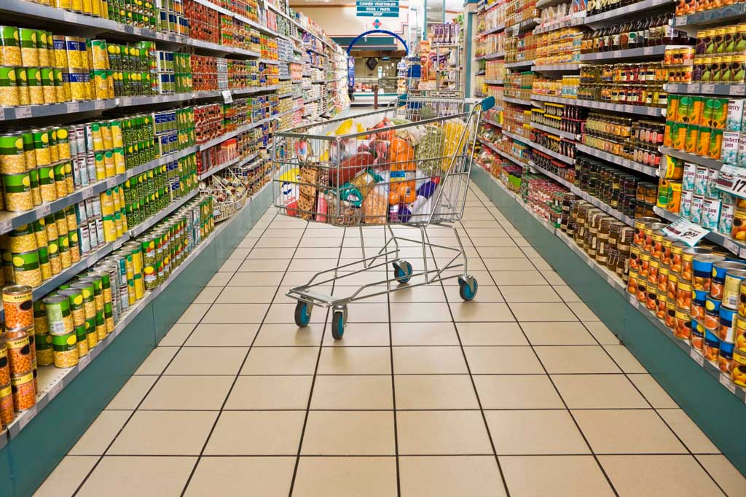

……………………......

**Χρήση:** ....................................................

**.**......................................................................

**Τι περιλαμβάνει:** ...........................................

................................................................................................................................................

**Που βρίσκεται:** .............................................

**Επισκέψεις:** ........................................................................................................................

...................................................................................................................................................

**Συναισθήματα:** .......................................................................................................................

**.**.................................................................................................................................................

**Αιτιολογία:** ........................................................................................................................

...................................................................................................................................................

**Συνολική περιγραφή:** .............................................................................................................

...................................................................................................................................................

...............................................................................................................................................................................................................................................................................................

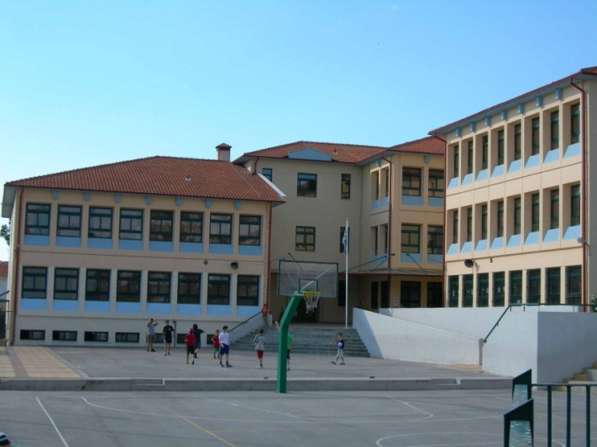

……………………..........

**Χρήση:** ....................................................

**.**......................................................................

**Τι περιλαμβάνει:** ...........................................

................................................................................................................................................

**Που βρίσκεται:** .............................................

**Επισκέψεις:** .............................................

..................................................................................................................................................

**Συναισθήματα:** .......................................................................................................................

**.**.................................................................................................................................................

**Αιτιολογία:** ........................................................................................................................

...................................................................................................................................................

**Συνολική περιγραφή:** .............................................................................................................

...................................................................................................................................................

...............................................................................................................................................

.......................................................................................................................................

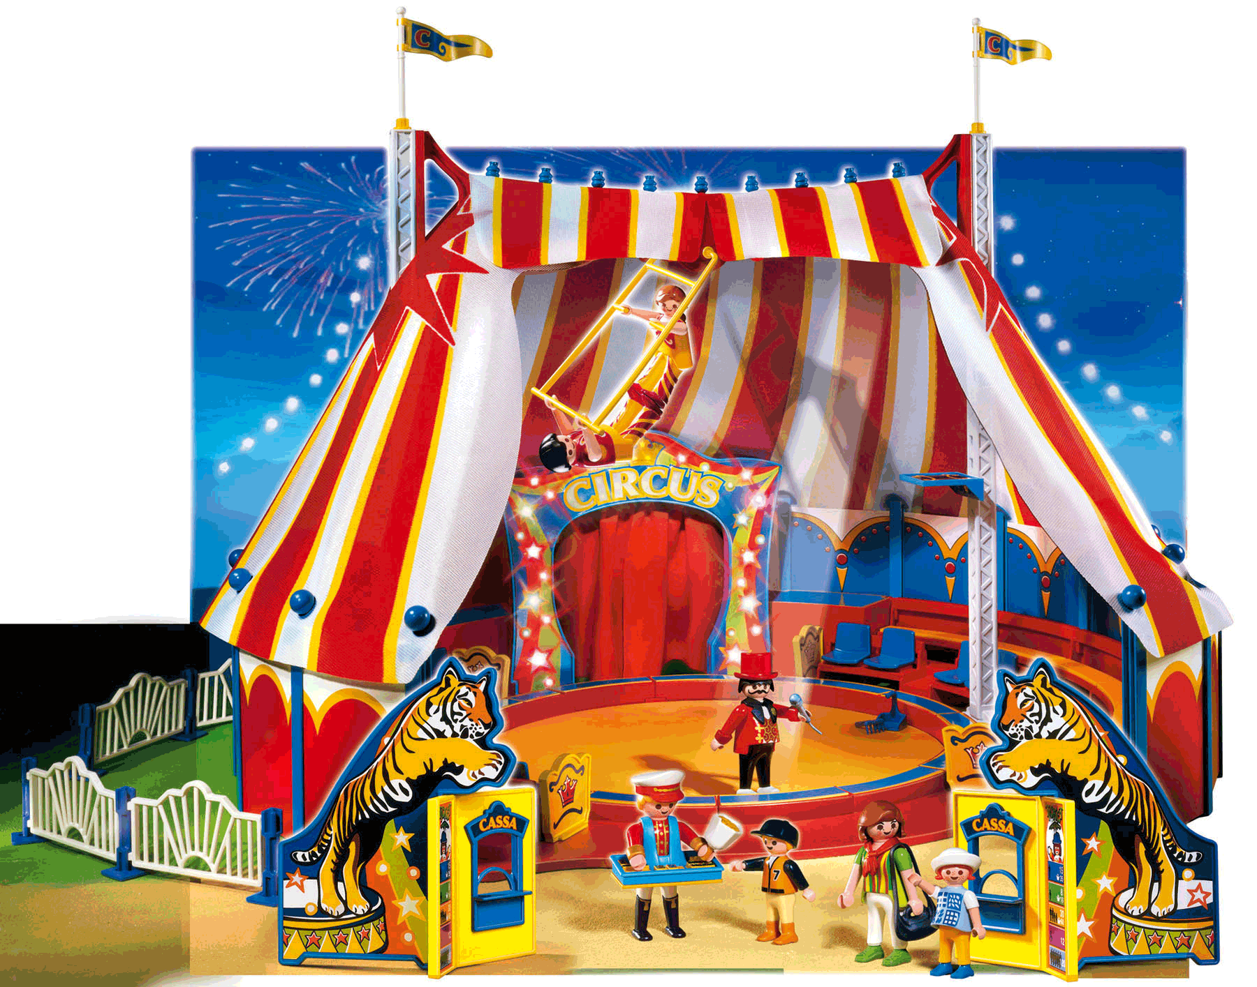

……………………......

**Χρήση:** ....................................................

**.**......................................................................

**Τι περιλαμβάνει:** ...........................................

................................................................................................................................................

**Που βρίσκεται:** .............................................

**Επισκέψεις:** .............................................

........................................................................

**Συναισθήματα:** .......................................................................................................................

**.**.................................................................................................................................................

**Αιτιολογία:** ........................................................................................................................

...................................................................................................................................................

**Συνολική περιγραφή:** .............................................................................................................

...................................................................................................................................................

...............................................................................................................................................................................................................................................................................................

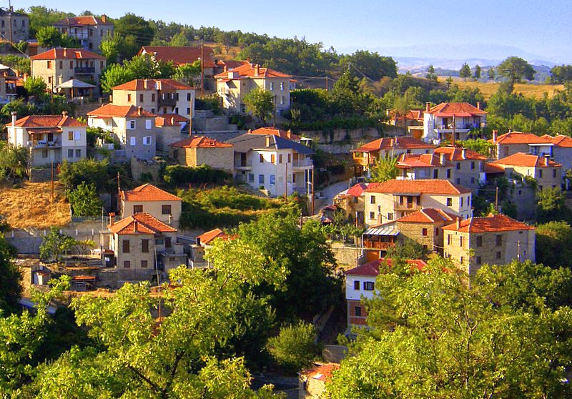

……………………..........

**Χρήση:** ....................................................

**.**......................................................................

**Τι περιλαμβάνει:** ...........................................

................................................................................................................................................

**Που βρίσκεται:** .............................................

**Επισκέψεις:** .......................................................................................................................

..................................................................................................................................................

**Συναισθήματα:** .......................................................................................................................

**.**.................................................................................................................................................

**Αιτιολογία:** ........................................................................................................................

...................................................................................................................................................

**Συνολική περιγραφή:** .............................................................................................................

...................................................................................................................................................

...............................................................................................................................................

.......................................................................................................................................

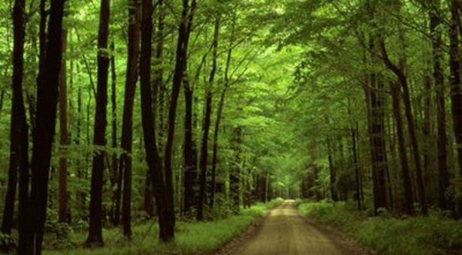

……………………......

**Χρήση:** ....................................................

**.**......................................................................

**Τι περιλαμβάνει:** ...........................................

................................................................................................................................................

**Που βρίσκεται:** .............................................

**Επισκέψεις:** ........................................................................................................................

**.**.................................................................................................................................................

**Συναισθήματα:** .......................................................................................................................

**.**.................................................................................................................................................

**Αιτιολογία:** ........................................................................................................................

...................................................................................................................................................

**Συνολική περιγραφή:** .............................................................................................................

...................................................................................................................................................

...............................................................................................................................................................................................................................................................................................

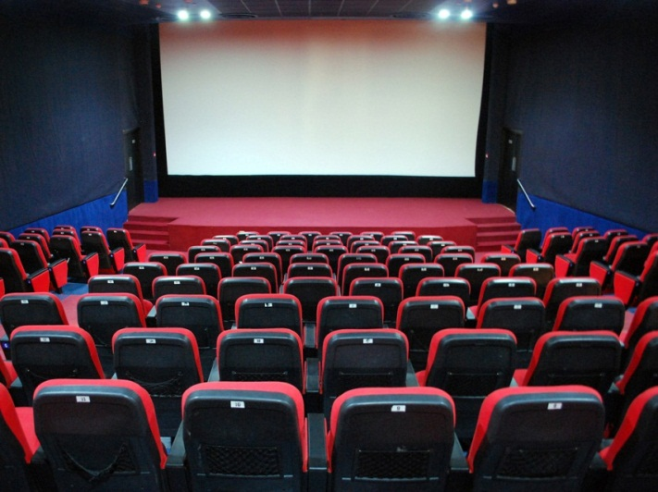

……………………..........

**Χρήση:** ....................................................

**.**......................................................................

**Τι περιλαμβάνει:** ...........................................

...................................................................... .........................................................................

**Που βρίσκεται:** .............................................

**Επισκέψεις:** ..............................................

..................................................................................................................................................

**Συναισθήματα:** .......................................................................................................................

**.**.................................................................................................................................................

**Αιτιολογία:** ........................................................................................................................

...................................................................................................................................................

**Συνολική περιγραφή:** .............................................................................................................

...................................................................................................................................................

...............................................................................................................................................

.......................................................................................................................................



……………………......

**Χρήση:** ...................................................................

**.**.....................................................................................

**Τι περιλαμβάνει:** ........................................................

.................................................................................................. .........................................................................

**Που βρίσκεται:** ...........................................................

**Επισκέψεις:** ...........................................................

......................................................................................

**Συναισθήματα:** .......................................................................................................................

**.**.................................................................................................................................................

**Αιτιολογία:** ........................................................................................................................

...................................................................................................................................................

**Συνολική περιγραφή:** .............................................................................................................

...................................................................................................................................................

...............................................................................................................................................................................................................................................................................................

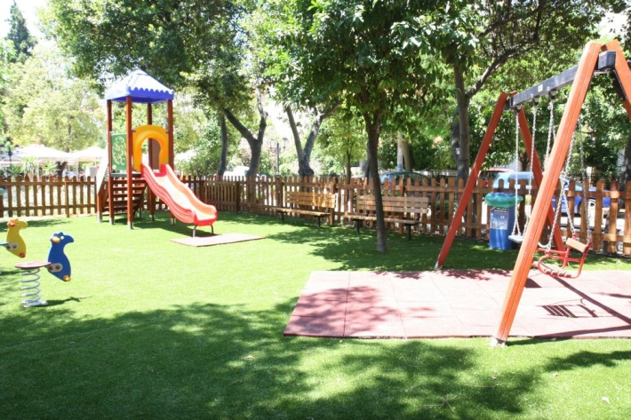

……………………..........

**Χρήση:** ....................................................

**.**......................................................................

**Τι περιλαμβάνει:** ........................................... .........................................................................

................................................................................................................................................

**Που βρίσκεται:** ........................................................................................................................

**Επισκέψεις:** ........................................................................................................................

..................................................................................................................................................

**Συναισθήματα:** .......................................................................................................................

**.**.................................................................................................................................................

**Αιτιολογία:** ........................................................................................................................

...................................................................................................................................................

**Συνολική περιγραφή:** .............................................................................................................

................................................................................................................................................

.......................................................................................................................................

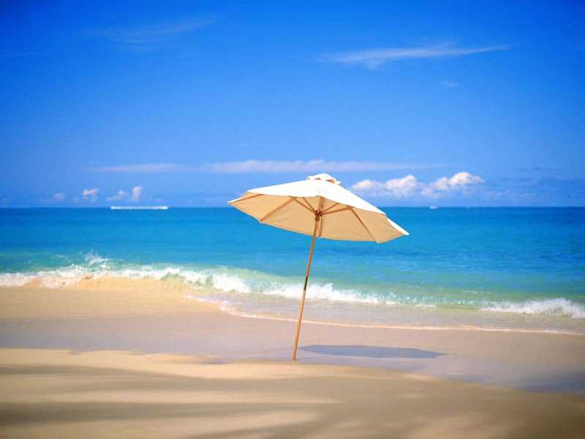

……………………......

**Χρήση:** ....................................................

**.**.......................................................................

**Τι περιλαμβάνει:** ...........................................

.........................................................................

**Που βρίσκεται:** .............................................

**Επισκέψεις:** .............................................

.........................................................................

..........................................................................

**Συναισθήματα:** .......................................................................................................................

**.**.................................................................................................................................................

**Αιτιολογία:** ........................................................................................................................

...................................................................................................................................................

**Συνολική περιγραφή:** .............................................................................................................

...................................................................................................................................................

...............................................................................................................................................................................................................................................................................................

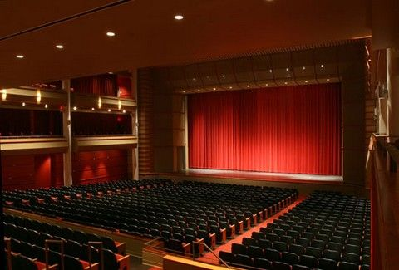

……………………..........

**Χρήση:** ....................................................

**.**............................................................ ..........

**Τι περιλαμβάνει:** ...........................................

................................................................................................................................................

**Που βρίσκεται:** .............................................

**Επισκέψεις:** ......................................................................................................................

..................................................................................................................................................

**Συναισθήματα:** .......................................................................................................................

**.**.................................................................................................................................................

**Αιτιολογία:** ........................................................................................................................

...................................................................................................................................................

**Συνολική περιγραφή:** .............................................................................................................

...................................................................................................................................................

...............................................................................................................................................

.......................................................................................................................................