**ΠΕΡΙΓΡΑΦΙΚΟΣ ΛΟΓΟΣ**

*Εξασκούμε την παρατηρητικότητα, την βελτίωση προφορικού και γραπτού λόγου. Φτιάχνουμε προτάσεις για την κάθε εικόνα, απαντώντας τις βοηθητικές ερωτήσεις (ποιος, πού, πότε, τι συνέβη, αποτέλεσμα). Στη συνέχεια συνδέουμε τις απαντήσεις και τις γράφουμε με την σειρά για να φτιάξουμε μια ολοκληρωμένη συνολική περιγραφή με νόημα.*

*Χρησιμοποιήστε την φαντασία σας και δώστε ένα τίτλο για την ιστορία σας!*

**Καλή και δημιουργική εξάσκηση!**

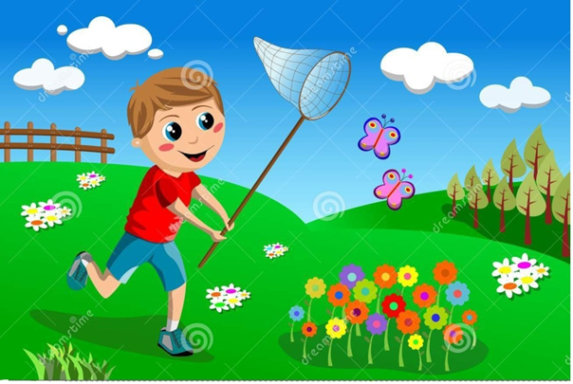

……………………......

**Ποιος:** ....................................................

**.**......................................................................

**Που:** .............................................................

...................................................................

**Πότε:** .............................................................

**Τι συνέβη:** ...................................................

..................................................................................................................................................

**Αποτέλεσμα:** .......................................................................................................................

**.**.................................................................................................................................................

**Συνολική περιγραφή:** .............................................................................................................

...................................................................................................................................................

................................................................................................................................................... ..................................................................................................................................................

................................................................................................................................................................................................................................................................................................

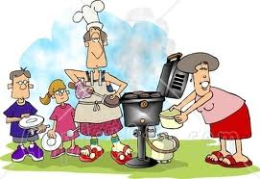

……………………......

**Ποιος:** ....................................................

**.**......................................................................

**Που:** .............................................................

.........................................................................

**Πότε:** .............................................................

**Τι συνέβη:** ...................................................

..................................................................................................................................................

**Αποτέλεσμα:** .......................................................................................................................

**.**.................................................................................................................................................

**Συνολική περιγραφή:** .............................................................................................................

...................................................................................................................................................

................................................................................................................................................... ..................................................................................................................................................

................................................................................................................................................................................................................................................................................................

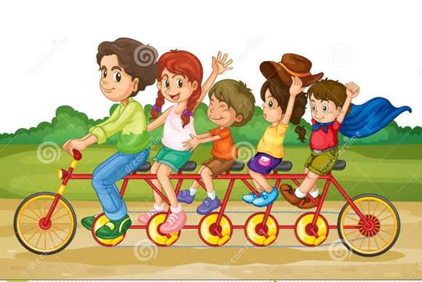

……………………......

**Ποιος:** ..........................................................

**.**........................................... ...........................

**Που:** ..............................................................

.......................................................................

**Πότε:** ..............................................................

**Τι συνέβη:** ...................................................

……………………………………………………..

**Αποτέλεσμα:** .......................................................................................................................

**.**.................................................................................................................................................

**Συνολική περιγραφή:** .............................................................................................................

...................................................................................................................................................

..................................................................................................................................................

..................................................................................................................................................

...............................................................................................................................................

.......................................................................................................................................

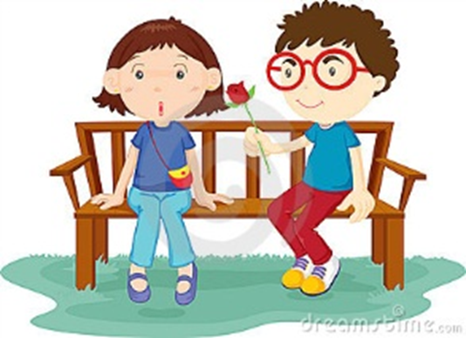

……………………......

**Ποιος:** ..........................................................

**.**........................................... ...........................

**Που:** ..............................................................

........................................................................

**Πότε:** ..............................................................

**Τι συνέβη:** ..................................................

..................................................................................................................................................

**Αποτέλεσμα:** .......................................................................................................................

**.**.................................................................................................................................................

**Συνολική περιγραφή:** .............................................................................................................

...................................................................................................................................................

..................................................................................................................................................

................................................................................................................................................................................................................................................................................................

.......................................................................................................................................



……………………......

**Ποιος:** ...................................................

**.**.....................................................................

**Που:** ...........................................................

.....................................................................

**Πότε:** ...........................................................

**Τι συνέβη:**…………………………………….

…………………………………………………

**Αποτέλεσμα:** .......................................................................................................................

**.**.................................................................................................................................................

**Συνολική περιγραφή:** .............................................................................................................

...................................................................................................................................................

................................................................................................................................................... .................................................................................................................................................................................................................................................................................................................................................................................................................................................

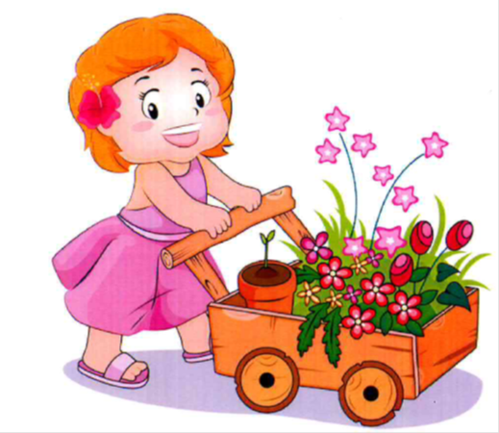

……………………......

**Ποιος:** ..........................................................

**.**........................................... ...........................

**Που:** ..............................................................

..............................................................................

**Πότε:** ..............................................................

**Τι συνέβη:** ........................................................

**.**.............................................................................

**Αποτέλεσμα:** ...................................................

……………………………………………………….

…………………………………………………………………………………………………………

**Συνολική περιγραφή:** .............................................................................................................

...................................................................................................................................................

...................................................................................................................................................................................................................................................................................................

...............................................................................................................................................

.......................................................................................................................................



……………………......

**Ποιος:** ...............................................................

**.**........................................... ................................

**Που:** ..................................................................

.............................................................................

**Πότε:** ..................................................................

**Τι συνέβη:** .......................................................

**.**............................................................................

**Αποτέλεσμα:** .......................................................................................................................

**.**.................................................................................................................................................

**Συνολική περιγραφή:** .............................................................................................................

...................................................................................................................................................

..................................................................................................................................................

.....................................................................................................................................................................................................................................................................................................

..............................................................................................................................................

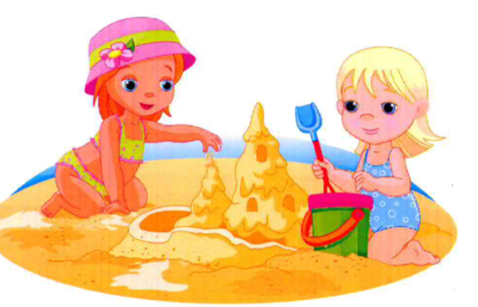……………………......

**Ποιος:** ...................................................

**.**.....................................................................

**Που:** ...........................................................

.....................................................................

**Πότε:** ...........................................................

**Τι συνέβη:** ................................................

..................................................................................................................................................

**Αποτέλεσμα:** .......................................................................................................................

**.**.................................................................................................................................................

**Συνολική περιγραφή:** .............................................................................................................

...................................................................................................................................................

....................................................................................................................................................................................................................................................................................................................................................................................................................................................................................................................................................................................................



……………………......

**Ποιος:** ......................................................

**.**.......................................................................

**Που:** ..............................................................

**Πότε:** ........................................................

**.**...............................................................................

**Τι συνέβη:** ...................................................

..................................................................................................................................................

**Αποτέλεσμα:** .......................................................................................................................

**.**.................................................................................................................................................

**Συνολική περιγραφή:** .............................................................................................................

...................................................................................................................................................

...................................................................................................................................................................................................................................................................................................

...............................................................................................................................................

............................................................................................................................................

....................................................................................................................................

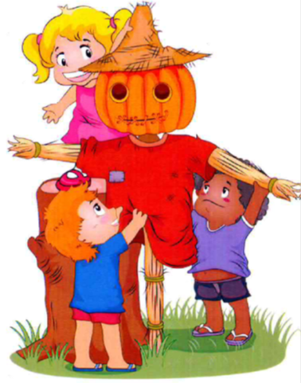

……………………......

**Ποιος:** .............................................................................

**.**...............................................................................................

**Που:** ......................................................................................

**Πότε:** ................................................................................

**.**..........................................................................................................

**Τι συνέβη:** ...........................................................................

.................................................................................................

**Αποτέλεσμα:** ........................................................................

**.**.................................................................................................................................................

**Συνολική περιγραφή:** .............................................................................................................

...................................................................................................................................................

...................................................................................................................................................................................................................................................................................................

...............................................................................................................................................

............................................................................................................................................

......................................................................................................................................



……………………......

**Ποιος:** ....................................................

**.**......................................................................

**Που:** .............................................................

........................................................................

**Πότε:** .............................................................

**Τι συνέβη:** ...................................................

..................................................................................................................................................

**Αποτέλεσμα:** .......................................................................................................................

**.**.................................................................................................................................................

**Συνολική περιγραφή:** .............................................................................................................

...................................................................................................................................................

....................................................................................................................................................................................................................................................................................................................................................................................................................................................................................................................................................................................................

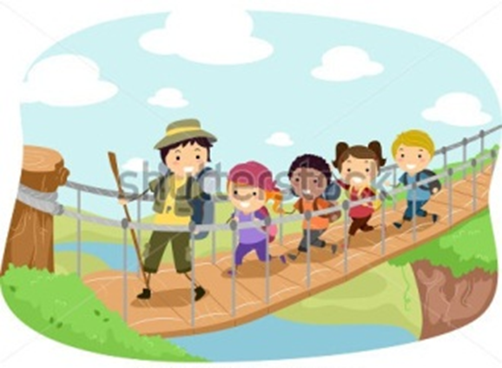

……………………......

**Ποιος:** .....................................................

**.**............................................................ ..........

**Που:** ..............................................................

**Πότε:** ........................................................

**.**...............................................................................

**Τι συνέβη:** ...................................................

........................................................................

**Αποτέλεσμα:** .......................................................................................................................

**.**.................................................................................................................................................

**Συνολική περιγραφή:** .............................................................................................................

...................................................................................................................................................

...................................................................................................................................................................................................................................................................................................

...............................................................................................................................................

............................................................................................................................................

......................................................................................................................................

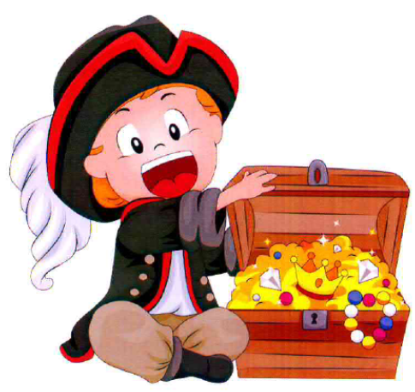……………………......

**Ποιος:** .....................................................

**.**............................................................ ..........

**Που:** ..............................................................

**Πότε:** ........................................................

**.**...............................................................................

**Τι συνέβη:** ...................................................

........................................................................

**Αποτέλεσμα:** .......................................................................................................................

**.**.................................................................................................................................................

**Συνολική περιγραφή:** .............................................................................................................

...................................................................................................................................................

...................................................................................................................................................................................................................................................................................................

...............................................................................................................................................

............................................................................................................................................

Έλενα Ταματτίρη - Λογοπαθολόγος